**Step1**: Validated whether the **Application pool** for the website is started or not.

While checking, that was in Stopped status.

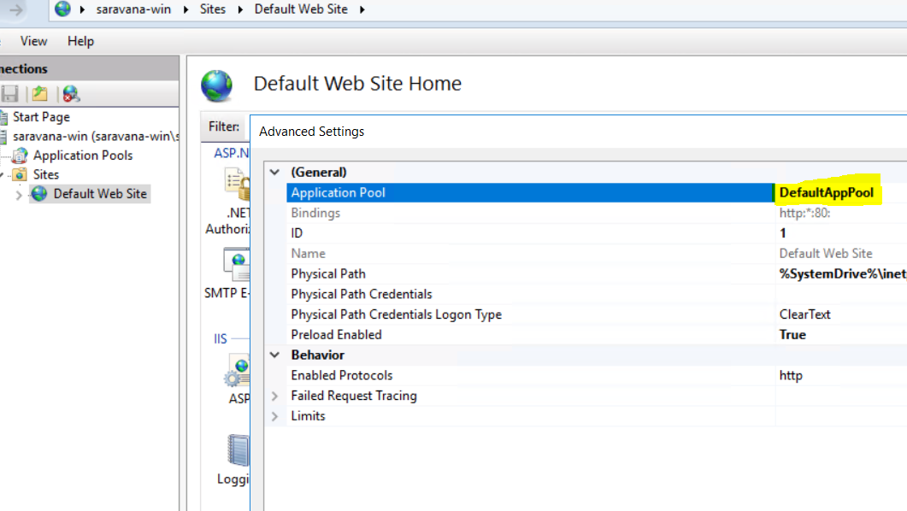

**********************************************************************************

**Step2**: So tried to start that application pool. But again that Application pool moved to stopped status.

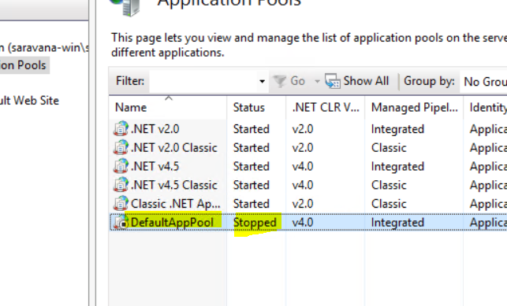

**********************************************************************************

**Step3**: So tried to analyse the events in our IIS server. As per Event log details, **username** and **password was shown like invalid**. Also because of this Application disabled.

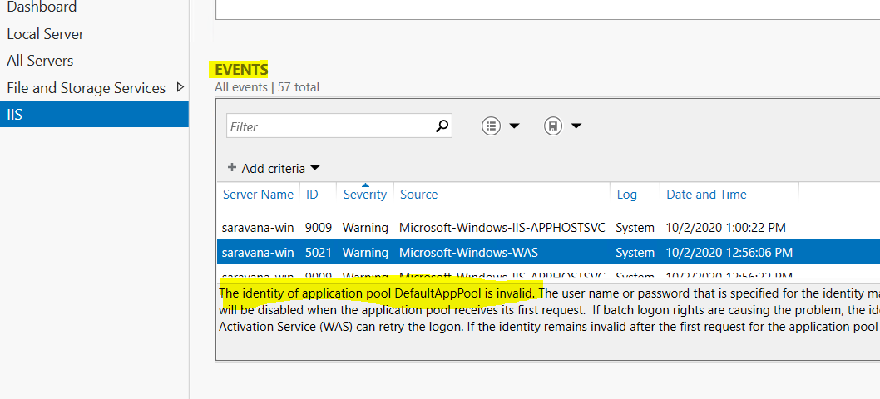

**********************************************************************************

**Step4**: So tried to set new “**identity”** for our application pool. After that moved to the Application pool setting. And started the Default Application Pool. This approach fixed this issue.

After this I could access the below URL Successfully.

<http://localhost:80>

